|  |  |  |  |
| --- | --- | --- | --- |
| **SET OPPERATIONS** | | | |
| **Union** | **Intersection** | **Difference** | **XOR** |
| **Size:** Worst case meaning there are no DUPLICATES, the size is Set A and Set B added together | **Size:** Worst case is that everything in a set is also in the other set. So, the size is set with the LEAST elements | **Size:** The size of the thing from which the other set is being removed. | **Size:** The size of the union of the set minus the intersection of the set |
| Image result for set union | Image result for set union | Image result for set difference notation | Image result for set xor |
| Everything in SET A plus everything is SET B | Things that are in BOTH set A and in set B | Everything in set A EXCEPT the things that are also in B | Everything in set A that is not is B and everything in B that is not in A |

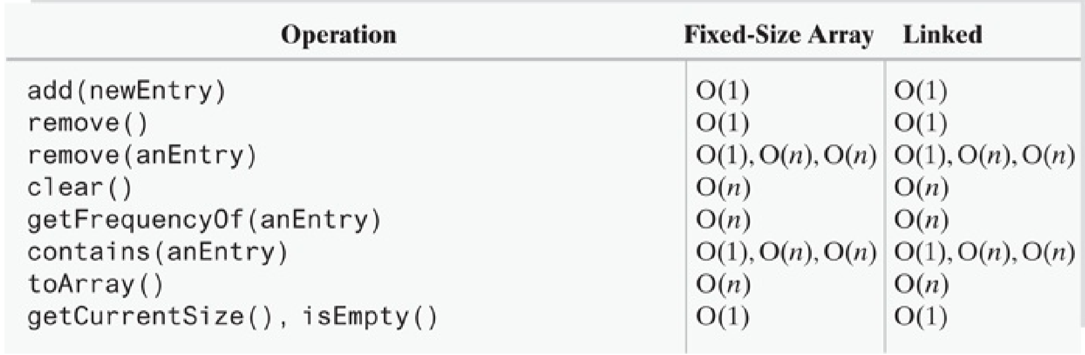

|  |  |
| --- | --- |
| InsertAtFront(data) | O(1) |
| InsertAtTail(data) | O(n) for singly linked list and O(1) for doubly,circular |
| size | O(n) |
| RemoveatFront | O(1) |
| RemoveAtTail | O(n) |
| Remove | O(n) |
| Remove for circular doubly | O(1) |